Raspberry Pi 3 Temperature Sensor DS18B20

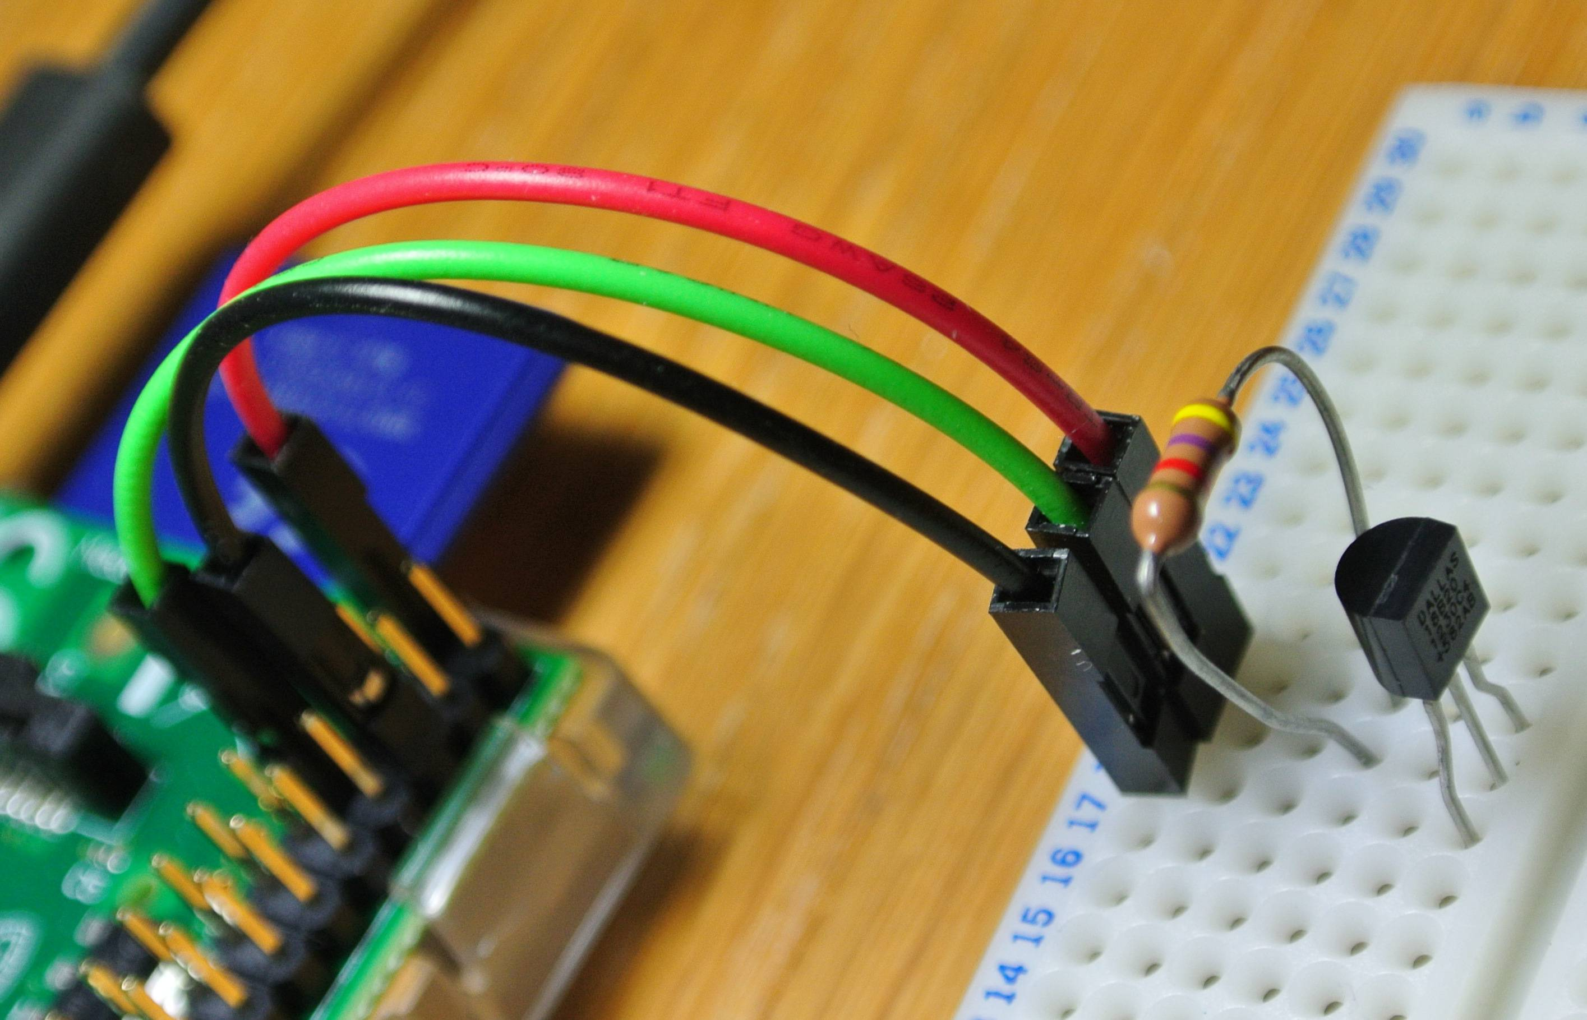

From left : GND(pi - 6) ,Output (pi- 7), VCC(pi- 1)

Resistor 4.7KOhm (Vcc-Output) (yellow side at Vcc)

Turn on your raspberry pi and let's begin.

**First step:**

First we need to config a file.

Do that by typing: sudo nano /boot/config.txt

This file let's you config your booting.

Here you search for dtoverlay

When you have found it just correct it to: dtoverlay=w1-gpio,gpiopin=4

Type sudo reboot, to reboot your device

**Second step:**

Type:

sudo modprobe w1-gpio && sudo modprobe w1_therm

ls -l /sys/bus/w1/devices/

cat /sys/bus/w1/devices/28-000004fda4a6/w1_slave

!!!WARNING!!!

My sensor is 28-000004fda4a6 yours may be different, so just replace it!

**Third step:**

I will attach a file that contains the tempTest.py

**import time**

**try:**

**while True:**

**tempfile = open("/sys/bus/w1/devices/28-000004fda4a6/w1_slave")**

**thetext = tempfile.read()**

**tempfile.close()**

**tempdata = thetext.split("\n")[1].split(" ")[9]**

**temperature = float(tempdata[2:])**

**temperature = temperature / 1000**

**print temperature**

**time.sleep(1)**

**except KeyboardInterrupt:**

**pass**